
THE INTERNATIONAL SCHOOL BANGALORE
GRADE 8 & 9 – NONVERBAL ENTRANCE EXAMINATION DETAILS

- SYLLABUS OUTLINE

In the Nonverbal Reasoning paper, students are expected to demonstrate pattern recognition, logical thinking, and visual problem-solving skills. The questions are designed to assess innate reasoning ability and do not require prior subject knowledge or curriculum-based learning.

Students will be presented with a variety of visual puzzles involving shapes, sequences, spatial patterns, and relationships between figures. These tasks test their ability to observe, compare, and deduce patterns based purely on visual input.

- QUESTION PAPER PATTERN
- Nature of Questions: Multiple Choice Questions (MCQs)
- Number of Questions: 20
- Duration: 30 minutes

- Sample Questions

- Which is the odd one out? Circle the letter.
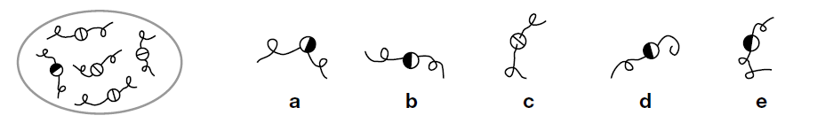

Answer : b
2. Which one comes next? Circle the letter.
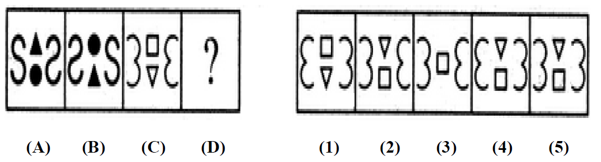

Answer : (4)

3. Decide which of the five shapes goes with the third one to make a pair like the two on the left.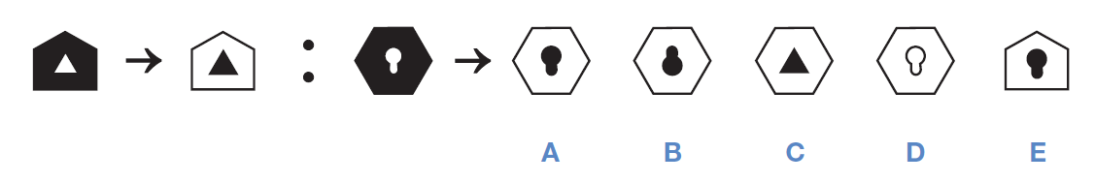

Answer : A

4. In the boxes on the left are shapes and the code letters that go with them. The top letters mean something different to the bottom ones. You must decide how the letters go with the shapes. Then find the correct code for the test shape from the set of five codes on the right.
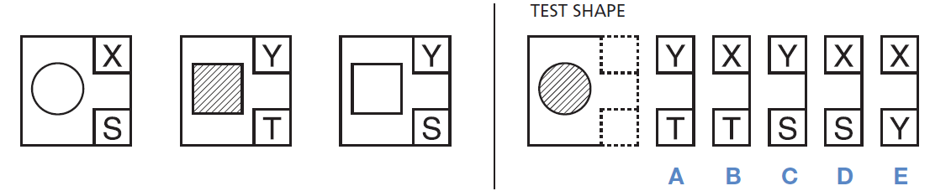
Answer : B

